**Exercise 2: Implementing the Factory Method Pattern**

**Scenario:**

You are developing a document management system that needs to create different types of documents (e.g., Word, PDF, Excel). Use the Factory Method Pattern to achieve this.

**Document.java**

**package** Factory;

**import** java.io.File;

**import** java.io.IOException;

**public** **interface** Document

{

**void** open();

}

**DocumentFactory.java**

**package** Factory;

**public** **abstract** **class** DocumentFactory

{

**public** **abstract** Document createDocument();

}

**WordDocumentFactory.java**

**package** Factory;

**public** **class** WordDocumentFactory **extends** DocumentFactory {

@Override

**public** Document createDocument() {

**return** **new** WordDocument();

}

}

**WordDocument.java**

**package** Factory;

**import** java.io.File;

**import** java.io.FileWriter;

**import** java.io.IOException;

**public** **class** WordDocument **implements** Document

{

@Override

**public** **void** open()

{

**try**

{

File file = **new** File("WordDocument.docx");

FileWriter writer = **new** FileWriter(file);

writer.write("This is a Word document.");

writer.close();

System.***out***.println("Word document created at: " + file.getAbsolutePath());

}

**catch** (IOException e)

{

System.***out***.println("Error creating Word document: " + e.getMessage());

}

}

}

**PdfDocumentFactory.java**

**package** Factory;

**public** **class** PdfDocumentFactory **extends** DocumentFactory {

@Override

**public** Document createDocument() {

**return** **new** PdfDocument();

}

**PdfDocument.java**

**package** Factory;

**import** java.io.File;

**import** java.io.FileWriter;

**import** java.io.IOException;

**public** **class** PdfDocument **implements** Document {

@Override

**public** **void** open() {

**try** {

File file = **new** File("PdfDocument.pdf");

FileWriter writer = **new** FileWriter(file);

writer.write("This is a PDF document.");

writer.close();

System.***out***.println("PDF document created at: " + file.getAbsolutePath());

} **catch** (IOException e) {

System.***out***.println("Error creating PDF document: " + e.getMessage());

}

}

}

**ExcelDocumentFactory.java**

**package** Factory;

**public** **class** ExcelDocumentFactory **extends** DocumentFactory {

@Override

**public** Document createDocument() {

**return** **new** ExcelDocument();

}

}

**ExcelDocument.java**

**package** Factory;

**import** java.io.File;

**import** java.io.FileWriter;

**import** java.io.IOException;

**public** **class** ExcelDocument **implements** Document {

@Override

**public** **void** open() {

**try** {

File file = **new** File("ExcelDocument.xlsx");

FileWriter writer = **new** FileWriter(file);

writer.write("This is an Excel document.");

writer.close();

System.***out***.println("Excel document created at: " + file.getAbsolutePath());

} **catch** (IOException e) {

System.***out***.println("Error creating Excel document: " + e.getMessage());

}

}

}

**DocumentFactoryTest.java**

**package** Factory;

**public** **class** DocumentFactoryTest {

**public** **static** **void** main(String[] args) {

DocumentFactory wordFactory = **new** WordDocumentFactory();

Document wordDoc = wordFactory.createDocument();

wordDoc.open();

DocumentFactory pdfFactory = **new** PdfDocumentFactory();

Document pdfDoc = pdfFactory.createDocument();

pdfDoc.open();

DocumentFactory excelFactory = **new** ExcelDocumentFactory();

Document excelDoc = excelFactory.createDocument();

excelDoc.open();

}

}

**OUTPUT:**

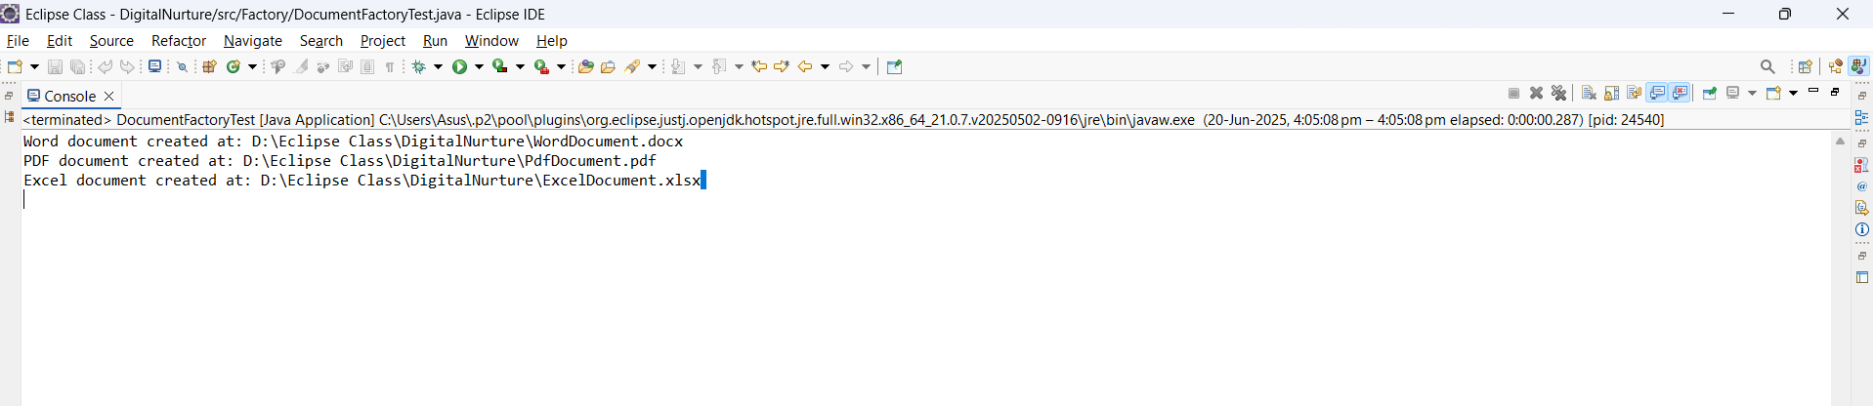

Word, Pdf, Excel Documents are created

